**Assignment –4**

Retrieving Information from Tables.

**1)** Write a select command that produces the order number, amount, and date for all rows in the Orders table.

**Answer –**

**select Onum,Amt,Odate from orders;**

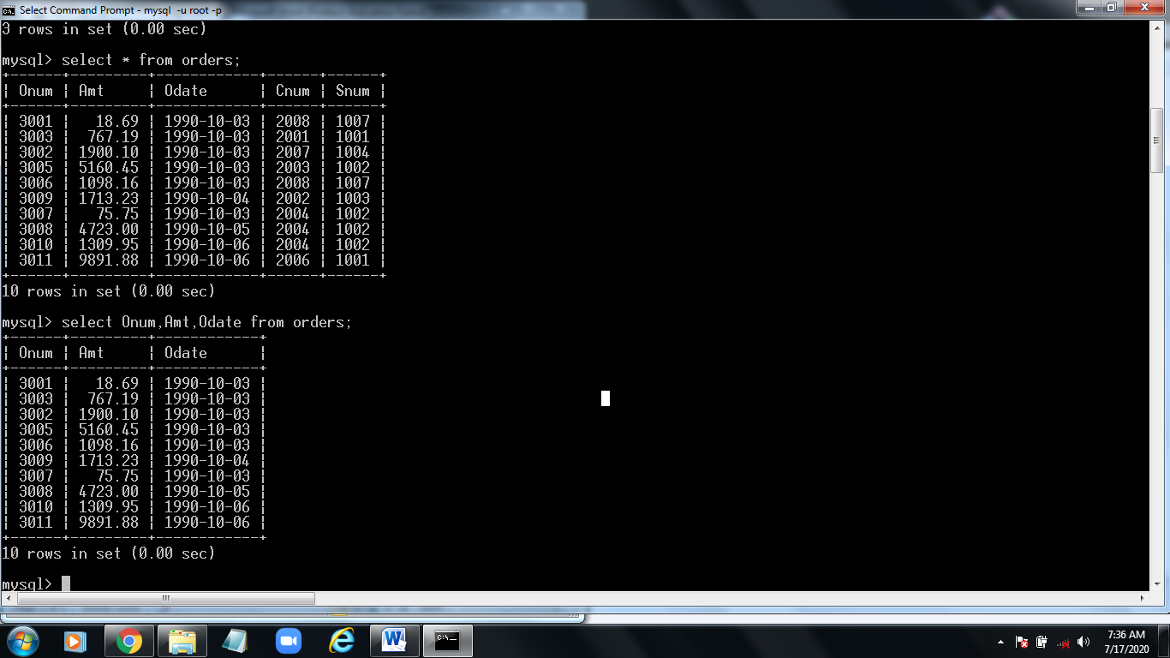

**2)** Write a query that produces all rows from the Customers table for which the

salesperson’s number is 1001.

**Answer –**

**select * from customers where Snum=1001;**

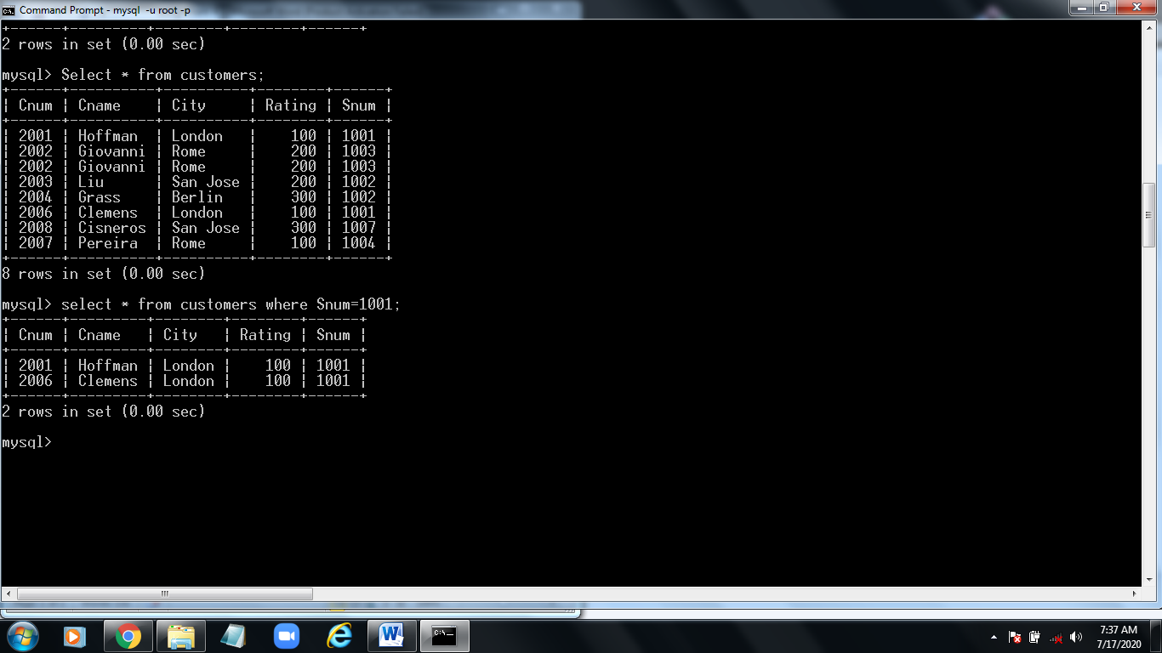

**3)** Write a query that displays the Salespeople table with the columns in the

following order: city, sname, snum, comm.

**Answer –**

**select City,Sname,Snum,Comma from salespeople;**

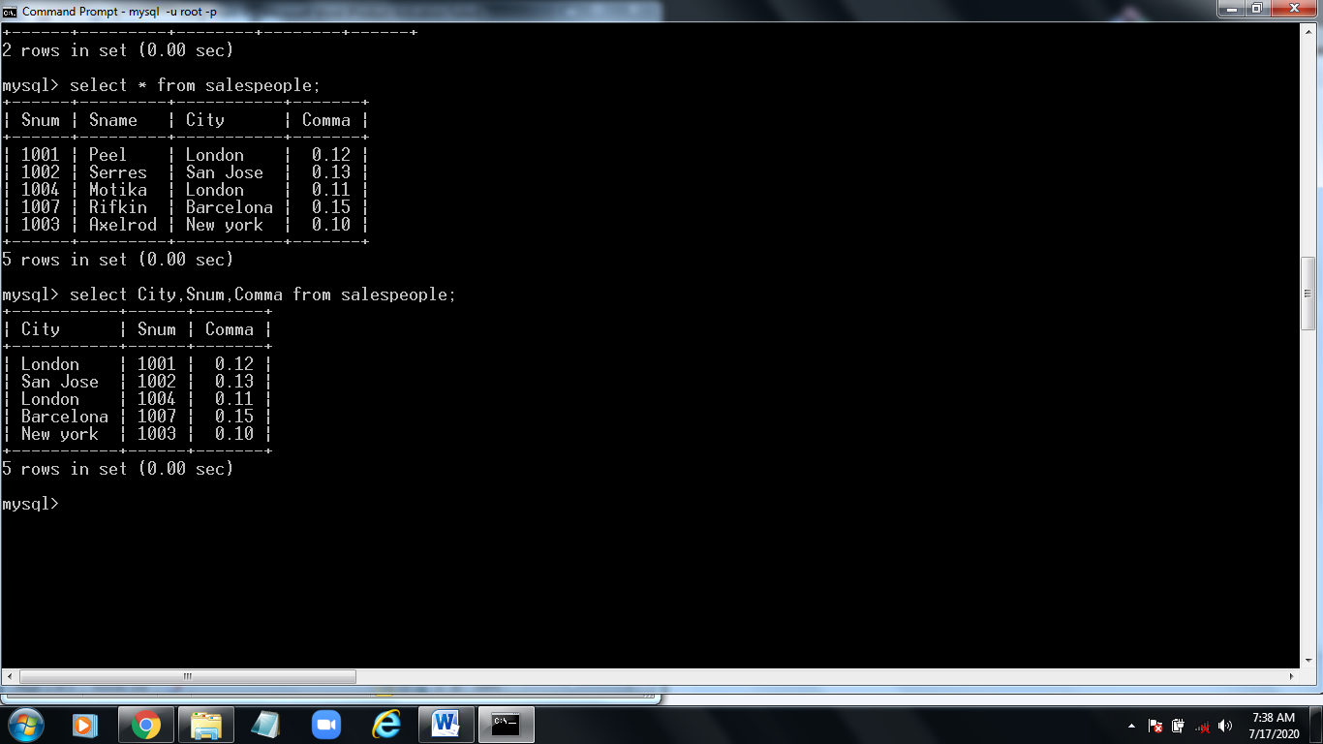

**4)** Write a select command that produces the rating followed by the name of each

customer in San Jose.

**Answer –**

**select Rating,Cname,from customers where city=”San Jose”;**

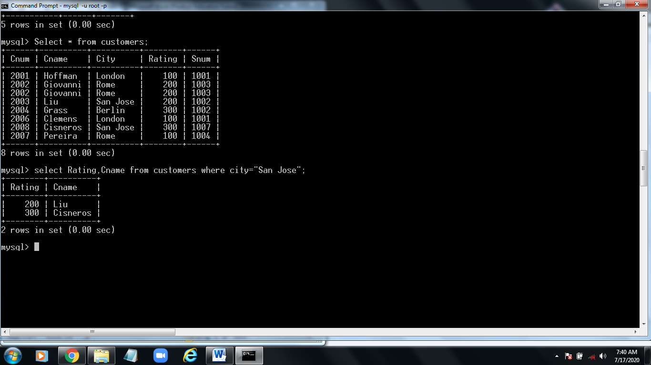

**5)** Write a query that will produce the snum values of all salespeople (suppress the duplicates) with orders in the Orders table.

**Answer –**

**select distinct Snum , Oname from salespeople order by Snum;**

